
A 11

Sreenidhi Institute of Science & Technology
(An Autonomous Institution)
Code No: 111EC08

B. TECH. II – Year II – Semester Examinations, May, 2013 (Regular)
SIGNALS AND SYSTEMS ( ECM )

Time: 3 Hours Max. Marks : 70

Note : No additional answer sheets will be provided.

Part-A (Objective Type)
Max.Marks:20

Answer all QUESTIONS.
- When are a set of complex functions mutually orthogonal over the interval (t1, t2)?
- List out the conditions that must be satisfied for the Fourier Series to exist for a periodic signal?
- Define Transfer function of a system?
- Find the inverse Laplace Transform of the expression given below
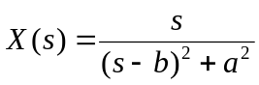
- Define the terms:
a. Signal bandwidth b. System bandwidth
- What is the difference between energy Spectral Density and Power spectral density?
- What are the two types of correlation functions. Give out the expressions?
- What is an anti-aliasing filter?
- Determine the Z-Transform and ROC of a finite duration signal?
x(n) = {1, 2, 6, -2,0, 3}
- State the following properties of Z-transform:
a) Time shifting b) Scaling
Part – B
Max. Marks: 50

ANSWER ANY FIVE QUESTIONS. EACH QUESTION CARRIES 10 MARKS.

- a) Show that the functions Sin(n₀t) and Cos(n₀t) are orthogonal over any interval {t₀ , (t₀ + 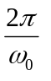} for integral values of n and m. [ 5 ]
b) A rectangular function is defined as, [ 5 ]
x(t) = 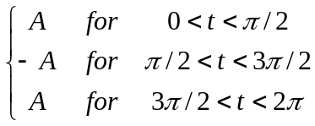
Approximate the above function by A cost between the intervals (0, 2π) such that the mean square error is minimum.

2. a) Find the trigonometric Fourier Series for the Triangular Wave shown below. [ 5 ]
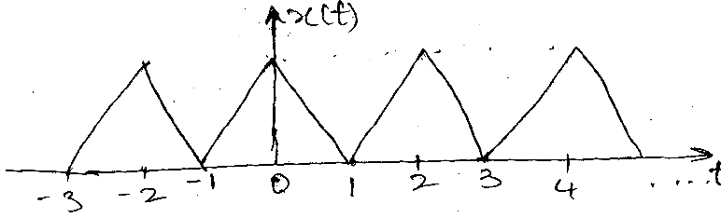
b) State and prove Parsevals Theorm for Fourier Series? [ 5 ]
3. Find the Fourier Transform of the following signals? [ 5 + 5 ]
i) Double sided Exponential signal ii) Gate Function
4. a) Using Convolution Theorem, find inverse Laplace Transform of [ 5 ] 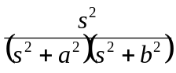
b) Obtain Laplace Transform of Periodic half – rectified sine wave form shown below. [ 5 ]
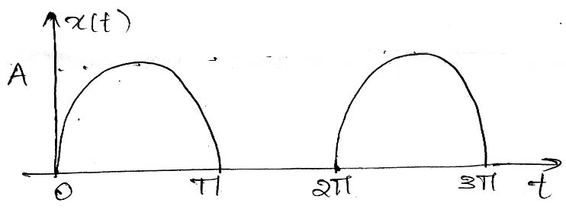
5. a) State whether the following systems are stable or unstable? [ 5 ]
i) h(t) = e^{-at}. u(t)
ii) h(n) = b^{n} ; n < 0
= a^{n} ; n >0
b) Derive the relation between bandwidth and rise-time. [ 5 ]
6. a) A filter has an impact x(t) = e^{-3t}. u(t) and transfer function, 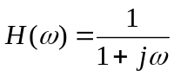
Find the energy spectral density of the output. [ 5 ]

b) Find the Convolution of two signals x(n) = {1, 1, 0, 1, 1} & [ 5 ]
h(n) = {1, -2,-3, 4} and represent then graphically.
7. a) A Low pass x(t) has a spectrum x(f) given by [ 5 ]
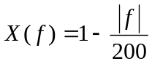; 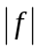< 200
Assume that x(t) is ideally sampled at fs = 300 Hz sketh the spectrum of Xs(t).
b) Consider the bandwidth pass signal x(t) with a spectrum shown below, check sampling theorem below; check sampling theorem by sketching the spectrum of the ideally sampled signal Xs(t) when, fs = 25 KHz. [ 5 ]
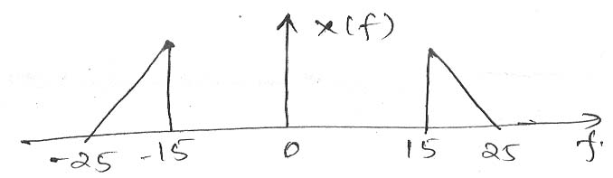
8. a) Find inverse Z-transform of 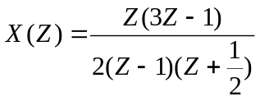; ROC 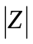 [ 5 ]
b) State and prove Initial Value Theorem and final value Theorem. [ 5 ]
-- 00 -- 00 --

